Republic of the Philippines

National Police Commission

Philippine National Police

**Cavite Police Provincial Office**

**CARMONA MUNICIPAL POLICE STATION**

Brgy Maduya, Carmona, Cavite

***carmonacavitepnp@gmail.com***

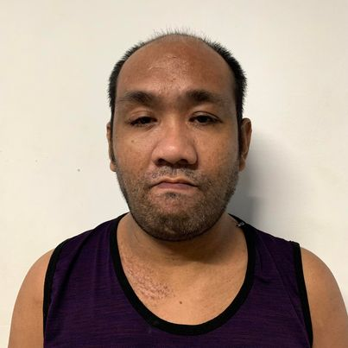

April 5, 2022

**CERTIFICATE OF DETENTION**

**TO WHOM IT MAY CONCERN**

**THIS IS TO CERTIFY** that one **LAURENCE PEREZ GARCIA**, male, 38 years old, born on **December 20, 1984**, single, resident of **1948K Baretta Compound, Gonzales St. Pandacan, Manila** was detained at this office since March 7, 2021 up to present and charged for the crime of **“Theft”** with Criminal Case Nr. **[CASENUMBER],** before the Office of Provincial Prosecutor, Imus, Cavite.

This certification is being issued upon request of interested party for whatever legal purposes it may serve.

Prepared by :

Laurence Garcia, **PSSg Anderson A Videña**

Detainee Custodial Officer